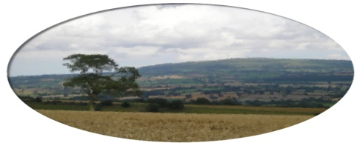
Munslow Parish Council

Nov 2020

MINUTES

Minutes of the extraordinary meeting of Munslow Parish Council held on Thursday 19th November 730pm 2020 via ZOOM.

Present ; Barbara Archer (Chair ) Linda Charie, David Marston, Antonia Bury, Mike Kelly , Val Fotheringham ,Ed Povey , Buster Evans.
Clive Leworthy (Clerk)

- Public Forum (limited to 15 minutes) members of the public may raise any issues with the Council during the public forum but not during the Council meeting unless invited to do so by the Chairman. Members of the public can join the meeting via ZOOM but cannot participate in the meeting once the public session is completed. Contact the Clerk for further info on joining the meeting.

2. Apologies for absence. Chris Meeson

- Declarations of Interest.
Declarations of Interest - Members are requested to declare any personal and/or prejudicial interests they may have in matters to be considered at this meeting in accordance with the terms of the Local Authorities (Model Code of Conduct) (England) Order 2001 issued under Section 51 Local Government Act 2000 as follows:

  - Declarations of personal interests NONE

  - Declarations of prejudicial interests NONE

- Approval of the minutes from meeting held on 5th November 2020

- Highways -
(a) To receive an update from the Working Group
Ed Povey advised that the Working Group had met again recently and would be producing a “Wishlist” of possible solutions for speed reduction , which could include , village gateway , village enhancement options with costings ,including community involvement and that this list would be presented to the Council for consideration at the January meeting. Council discussed budget options and various speed reduction initiatives. The Chair asked that this item be put on the Agenda for discussion at the January meeting.
(b) To consider a proposal that an application be submitted to the PCC for funding to support the purchase of VAS sign at the North of Aston Munslow. The Chair outlined the benefits of VAS signs in helping to reduce speed and that this should be seen as a starting point in options to reduce speeding through the Parish. Residents had expressed their concerns on many occasions about speeding and she felt it was important Council tried to act on this matter. The proposal from the Chair was that Munslow PC submit a bid to the PCC to support funding for the purchase of a VAS sign to be sited at the north end of Aston Munslow. 2nd by Anotnia Bury.
5 Votes in favour 3 Against Motion Approved. Clerk would submit a bid immdediately.

The Chair thanked Council for attending another meeting and would update them on any progress.

Next meeting 7th January 2021

