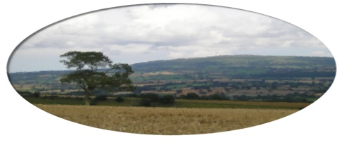
Munslow Parish Council

To All Councillors Jan 2020

You are hereby invited to attend the meeting of Munslow Parish Council, to be held on Thursday 2nd January 2020 at 7:30 pm in the Beambridge Clubroom. The business to be transacted is shown on the Agenda below.

Clive Leworthy
Clerk to the Parish Council

AGENDA

1. Public Forum (limited to 15 minutes) members of the public may raise any issues with the Council during the public forum but not during the Council meeting unless invited to do so by the Chairman.

2. Apologies for absence.

3. Declarations of Interest.

4. Approval of the minutes from meeting held on 7th Nov 2019

5. Matters Arising from those minutes that are not covered on the Agenda –

6. Urgent issues from members for discussion ( not voting) at item 14 - subject to approval of the Chairman.

7. Smartwater – To discuss the rollout of Smartwater kits. Event Sat 8th Feb 0930 -12 and other acitivity to support the rollout.

8. Reports
(a) Chairman
(b) Cllr Cecelia Motley
(c) Burial Ground

9. Clerk’s Update –

10. Finance
(a) Consider the accounting statement
(b) To consider & agree the Precept for 2020/21 (report attached)
(c) Consider payments for approval.
Clerk’s Salary Dec = £190.67
Clerks Expenses Dec = £7.65
Total = £198.32
Gary Trim EMO £ 81.85
Weborchard (Website) £228

11. Planning Matters
(a) Consider new applications
(b) Applications granted

12. Environmental and Highways issues:
(a) Environmental Maintenance Officer –
(b) General highways matters to include Traffic Calming & Village Gateway
Report on the meeting held with Graham Oliver PCC on 3rd Dec with Chair /Vice Chair /Clerk

(c) Flood Forum Group Review

13. Correspondence and communications

14. Urgent matters as agreed for discussion from item 4 above.

Next meeting Feb 6th 2020.

