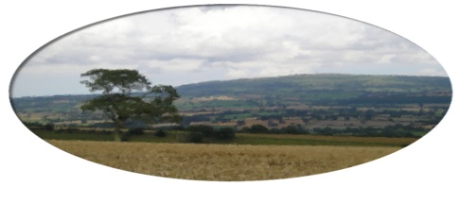
Munslow Parish Council

To All Councillors Feb 2021

You are hereby invited to attend the meeting of Munslow Parish Council, to be held on Thursday 4th February 2021 at 7:30 pm via ZOOM. The business to be transacted is shown on the Agenda below.

Topic: Munslow PC
Time: Feb 4, 2021 19:30 Greenwich Mean Time

Join Zoom Meeting
https://us02web.zoom.us/j/82877683961?pwd=Q2NDdnZQYTQ4UjlYSXpmU3QzTFN2Zz09

Clive Leworthy
Clerk to the Parish Council

Presentation by Mark Trafford Sales Manager Airband Community Internet UK
Airband is an independent internet service provider bringing high speed broadband to homes, business and industry in rural and hard-to-reach areas.
Airband work with the Department for Digital, Culture, Media & Sport, BDUK, local authorities and communities to build high availability infrastructure that residents, businesses and other ISPs can access to help overcome the UK’s digital divide.

AGENDA

1. Public Forum (limited to 15 minutes) members of the public may raise any issues with the Council during the public forum but not during the Council meeting unless invited to do so by the Chairman.

2. Apologies for absence.

- Declarations of Interest.

- Approval of the minutes from meeting held on 7th January 2021

- Matters Arising from those minutes that are not covered on the Agenda

6. Reports
(a) Chairman
(b) SC Cllr Cecelia Motley

7. Finance
(a) To review the accounting statement

(b) Consider payments for approval.
Clerk Salary Jan £156.67
Clerks Expenses Jan £29.69
HMRC £ 39.20

8 Planning Matters
(a) To Consider any new applications

9. Highways

(a) To receive an update on the PCC application.
(b) To receive an update and review the report from the Highways Working Group

10 . Census 2021 To receive a briefing on the Census 21 plans.

- Flooding – To review recent flooding reports

- Community Governance Review – To consider the planned review of Town /Parish Council
boundaries which will take place after the May elections.

13 Local Elections To receive an update on the Elections planned for May 6th

Date of Next Meeting Thursday 4th March 2021

