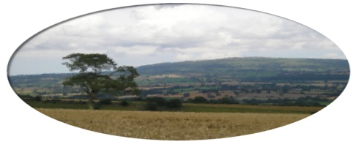
Munslow Parish Council

To All Councillors Oct 2020

You are hereby invited to attend the Extra Ordinary meeting of Munslow Parish Council to be held on Thursday 22nd October 2020 at 7:30 pm via ZOOM. The business to be transacted is shown on the Agenda below. Members of the public can join the meeting via ZOOM but cannot participate in the meeting once the public session is completed. Contact the Clerk for further info on joining the meeting.

Join Zoom Meeting Clive Leworthy is inviting you to a scheduled Zoom meeting.

Topic: Extra Ordinary Meeting
Time: Oct 22, 2020 19:30 Greenwich Mean Time

Join Zoom Meeting
https://us02web.zoom.us/j/82052261507?pwd=SytYeWpNN0pWekw0Tnp2MTc1UXNaQT09

Meeting ID: 820 5226 1507
Passcode: 489438

Clive Leworthy
Clerk to the Parish Council

AGENDA

- Public Forum (limited to 15 minutes) members of the public may raise any issues with the Council during the public forum but not during the Council meeting unless invited to do so by the Chairman. Members of the public can join the meeting via ZOOM but cannot participate in the meeting once the public session is completed. Contact the Clerk for further info on joining the meeting.

2. Apologies for absence.

- Declarations of Interest.
Declarations of Interest - Members are requested to declare any personal and/or prejudicial interests they may have in matters to be considered at this meeting in accordance with the terms of the Local Authorities (Model Code of Conduct) (England) Order 2001 issued under Section 51 Local Government Act 2000 as follows:

  - Declarations of personal interests

  - Declarations of prejudicial interests

- Approval of the minutes from meeting held on 1st October 2020

- Highways - Speeding
(a) To review a report from the Chair of recent meeting with Highways on 13th October
(b) To review and agree a way forward

Next meeting 5th November 2020.

