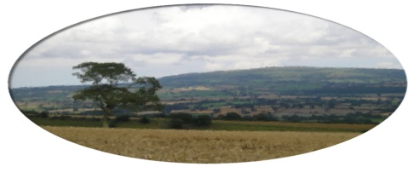
Munslow Parish Council

To All Councillors Nov 2020

You are hereby invited to attend the meeting of Munslow Parish Council to be held on Thursday 5th November 2020 at 7:30 pm via ZOOM. The business to be transacted is shown on the Agenda below. Members of the public can join the meeting via ZOOM but cannot participate in the meeting once the public session is completed. Contact the Clerk for further info on joining the meeting.

Join Zoom Meeting ; Clive Leworthy is inviting you to a scheduled Zoom meeting.

Topic: Munslow PC
Time: Nov 5, 2020 19:30

Join Zoom Meeting
https://us02web.zoom.us/j/88421587329?pwd=WUY4aWFoOFJ4dWRCOEhEZncxMThPUT09

Meeting ID: 884 2158 7329
Passcode: 798471

Clive Leworthy
Clerk to the Parish Council

AGENDA

- Public Forum (limited to 15 minutes) members of the public may raise any issues with the Council during the public forum but not during the Council meeting unless invited to do so by the Chairman. Members of the public can join the meeting via ZOOM but cannot participate in the meeting once the public session is completed. Contact the Clerk for further info on joining the meeting.

2. Apologies for absence. Antonia Bury

- Declarations of Interest.
Declarations of Interest - Members are requested to declare any personal and/or prejudicial interests they may have in matters to be considered at this meeting in accordance with the terms of the Local Authorities (Model Code of Conduct) (England) Order 2001 issued under Section 51 Local Government Act 2000 as follows:

  - Declarations of personal interests

  - Declarations of prejudicial interests

- Approval of the minutes from EO meeting held on 22nd October 2020

- Matters Arising from those minutes that are not covered on the Agenda

6. Reports
(a) Chairman
(b) Cllr Cecelia Motley

7. Finance
(a) Consider the accounting statement 2020/21 to date.
(b) Consider payments for approval.
Clerk’s Salary Oct £156.67
Clerks Expenses Oct = £ 29.69(Including Zoom sub)
HMRC = £39.20

8. Planning Matters
(a) Consider any new applications
(b) To receive a summary of recent planning training session – Chair / Cllr Fortheringham /Clerk

9.Highways

(a) To receive update from the Highways Sub Group

9 . Rememberance Sunday – To Confirm arrangements – Chair will lay wreath 11am on 11th Nov.

Next meeting 7th January 2021.

