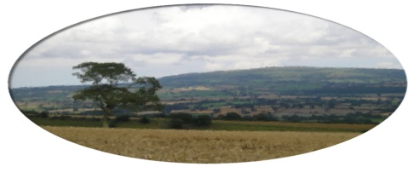
Munslow Parish Council

To All Councillors Nov 2020

You are hereby invited to attend the Extra Ordinary meeting of Munslow Parish Council to be held on Thursday 19th November 2020 at 7:30 pm via ZOOM. The business to be transacted is shown on the Agenda below. Members of the public can join the meeting via ZOOM but cannot participate in the meeting once the public session is completed. Contact the Clerk for further info on joining the meeting.

Join Zoom Meeting Clive Leworthy is inviting you to a scheduled Zoom meeting.

Topic: Extraordinary Meeting
Time: Nov 19, 2020 19:30 Greenwich Mean Time

Join Zoom Meeting
https://us02web.zoom.us/j/81794205767?pwd=U0s1elhzRS9sZHhlaXlUTVZ0VUloUT09

Meeting ID: 817 9420 5767
Passcode: 565478

Clive Leworthy
Clerk to the Parish Council

AGENDA

- Public Forum (limited to 15 minutes) members of the public may raise any issues with the Council during the public forum but not during the Council meeting unless invited to do so by the Chairman. Members of the public can join the meeting via ZOOM but cannot participate in the meeting once the public session is completed. Contact the Clerk for further info on joining the meeting.

2. Apologies for absence.

- Declarations of Interest.
Declarations of Interest - Members are requested to declare any personal and/or prejudicial interests they may have in matters to be considered at this meeting in accordance with the terms of the Local Authorities (Model Code of Conduct) (England) Order 2001 issued under Section 51 Local Government Act 2000 as follows:

  - Declarations of personal interests

  - Declarations of prejudicial interests

- Approval of the minutes from meeting held on 5th November 2020

- Highways -
(a) To receive an update from the Working Group
(b) To consider a proposal that an application be submitted to the PCC for funding to support the purchase of VAS sign at the North of Aston Munslow.

Next meeting 7th January 2021

